RED HAT SATELLITE UPGRADE (LEAPP)
RHEL8 to RHEL9 (Sat v6.16 to Sat v16.7)
Follow Upgrade Helper
https://access.redhat.com/labs/satelliteupgradehelper/
- Install required packages:
# satellite-maintain packages install leapp leapp-upgrade-el8toel9
- Let Leapp analyze your system:
# leapp preupgrade
Note
The first run will most likely report issues and inhibit the upgrade. Examine the report in the /var/log/leapp/leapp-report.txt file, answer all questions by using leapp answer, and manually resolve other reported problems.
- Run leapp preupgrade again and make sure that it does not report any more issues.
- Let Leapp create the upgrade environment:
# leapp upgrade
- Reboot the system to start the upgrade.
After the system reboots, a live system conducts the upgrade, reboots to fix SELinux labels and then reboots into the final Red Hat Enterprise Linux 9 system.
- Wait for Leapp to finish the upgrade. You can monitor the process with journalctl:
# journalctl -u leapp_resume -f
- Unlock packages:
# satellite-maintain packages unlock
- Verify the post-upgrade state. For more information, see Verifying the post-upgrade state in Upgrading from RHEL 8 to RHEL 9.
- Verify that the Leapp utility has finished all actions in the upgrade process and the system is ready to be used:
[ -e "/etc/systemd/system/leapp_resume.service" ] || ps -e | grep -q leapp && echo "Leapp has not finished the execution yet!"
Important
If you attempt to use the system before the upgrade is complete, serious issues could occur.
- Verify that the current OS version is RHEL 9. For example:
# cat /etc/redhat-release
- Check the OS kernel version. For example:
# uname -r
- Verify that network services are operational, for example, try to connect to a server using SSH.
- Perform post-upgrade tasks on the RHEL 9 system. For more information, see Performing post-upgrade tasks on the RHEL 9 system in Upgrading from RHEL 8 to RHEL 9.
- To manually remove packages from the exclude list, edit the /etc/dnf/dnf.conf configuration file and remove the desired Leapp packages from the exclude list. If any.
- To remove all packages from the exclude list:
# dnf config-manager --save --setopt exclude=''
- Remove the old kernel packages from the RHEL 9 system. For more information on removing kernel packages, see the Red Hat Knowledgebase solution What is the proper method to remove old kernels from a Red Hat Enterprise Linux system?
# yum remove –oldinstallonly
- Locate remaining RHEL 8 packages:
# rpm -qa | grep -e '\.el[78]' | grep -vE '^(gpg-pubkey|libmodulemd|katello-ca-consumer)' | sort
- Remove remaining RHEL 8 packages from your RHEL 9 system. To ensure that RPM dependencies are maintained, use the dnf remove command.
# dnf remove $(rpm -qa | grep \.el[78] | grep -vE 'gpg-pubkey|libmodulemd|katello-ca-consumer')
Important
This step might also remove third-party packages. Review the transaction before accepting to ensure no packages are unintentionally removed.
- Remove remaining Leapp dependency packages:
# dnf remove leapp-deps-el9 leapp-repository-deps-el9
- Optional: Remove all remaining upgrade-related data from the system: (we can do later)
# rm -rf /var/log/leapp /root/tmp_leapp_py3 /var/lib/leapp
- Replace the old rescue kernel and initial RAM disk with the current kernel and disk:

Remove the existing rescue kernel and initial RAM disk:
# rm /boot/vmlinuz-*rescue* /boot/initramfs-*rescue*

Reinstall the rescue kernel and related initial RAM disk:
# /usr/lib/kernel/install.d/51-dracut-rescue.install add "$(uname -r)" /boot "/boot/vmlinuz-$(uname -r)"
Re-evaluate and re-apply your security policies. Especially, change the SELinux mode to enforcing.
- Verification
Verify that the previously removed rescue kernel and rescue initial RAM disk files have been created for the current kernel:
# ls /boot/vmlinuz-*rescue* /boot/initramfs-*rescue*
# lsinitrd /boot/initramfs-*rescue*.img | grep -qm1 "$(uname -r)/kernel/" && echo "OK" || echo "FAIL"

Verify the rescue boot entry refers to the existing rescue files. See the grubby output:
# grubby --info /boot/vmlinuz-*rescue*

Review the grubby output and verify that no RHEL 8 boot entries are configured:
# grubby --info ALL

Verify that no files related to previous RHEL are present in the /boot/loader/entries file:
# grep -r ".el8" "/boot/loader/entries/" || echo "Everything seems ok."
- Lock packages:
# satellite-maintain packages lock
- Change SELinux to enforcing mode.
- Unset the subscription-manager release:
# subscription-manager release –unset

Upgrading Satellite Server
- Stop all Satellite services:
# satellite-maintain service stop
- Create a backup.
On a virtual machine, take a snapshot.
On a physical machine, create a backup.
- Start all Satellite services:
# satellite-maintain service start
- Ensure that the Satellite Maintenance repository is enabled:
- # subscription-manager repos \
--enable satellite-maintenance-6.17-for-rhel-9-x86_64-rpms
- Upgrade satellite-maintain to its latest version:
# satellite-maintain self-upgrade
- Use the health check option to determine if the system is ready for upgrade. When prompted, enter the hammer admin user credentials to configure satellite-maintain with hammer credentials. These changes are applied to the /etc/foreman-maintain/foreman-maintain-hammer.yml file.
# satellite-maintain upgrade check
(Here, we faced the hammer ping failed error, API was down due to some DB reindex and it was failed because of some duplicates Keys and Entries in DB, we noticed the same in Leapp Upgrade logs as well ,check the solution below this error)
- Because of the lengthy upgrade time, use a utility such as tmux to suspend and reattach a communication session. You can then check the upgrade progress without staying connected to the command shell continuously.
- Perform the upgrade:
# satellite-maintain upgrade run
- Reboot the system:
# reboot
- Once server is up, login to server, check the satellite service status, and hammer ping
# satellite-maintain service status -b
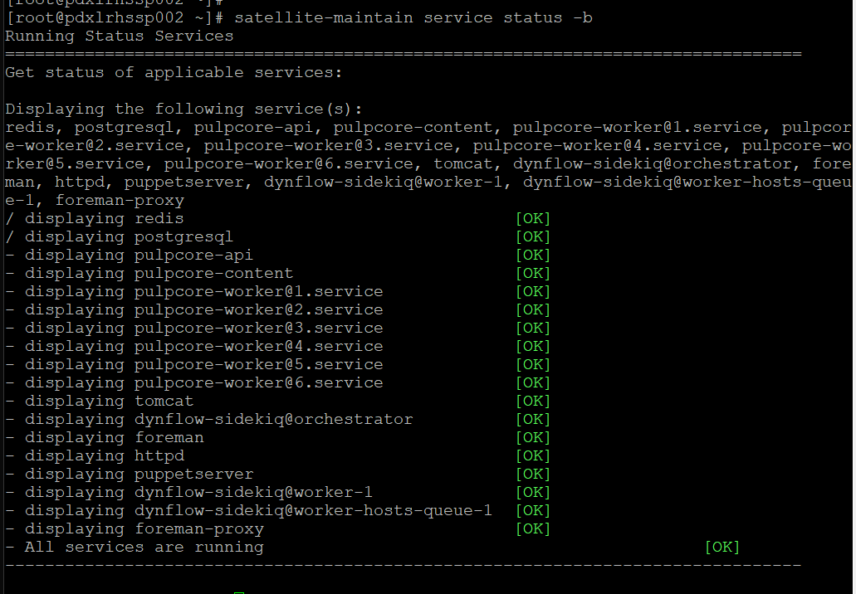
#
#
# hammer ping
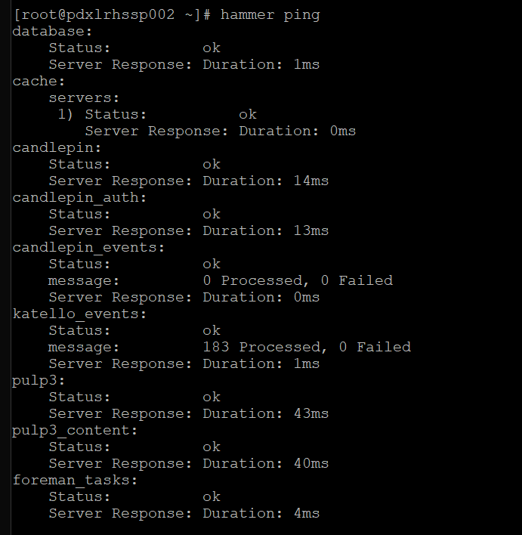

Login to GUI interface and make sure you refresh the manifest
- Contents Subscription Manage Manifest
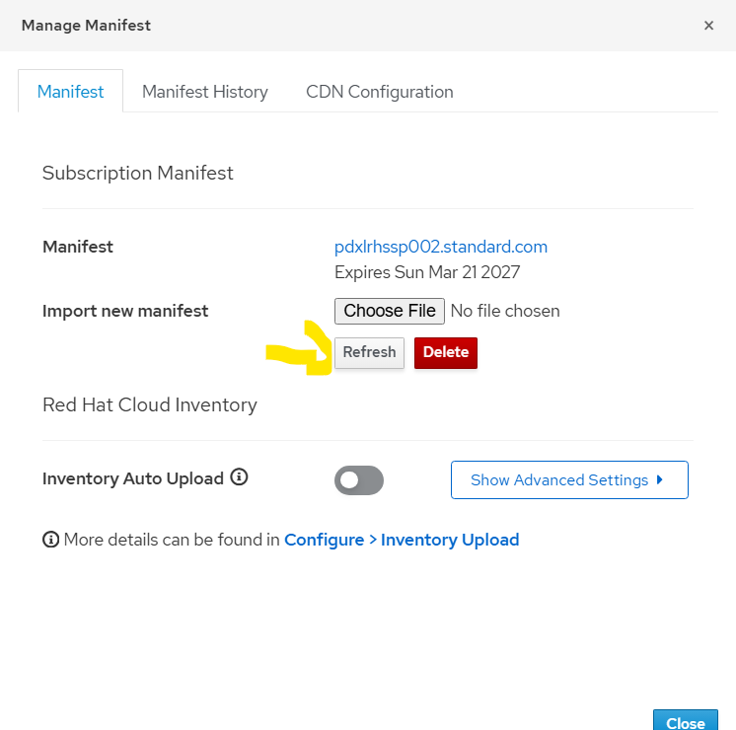

Try to Sync any repo and make sure it’s 100% synced without any work.
Try to register any server or try to patch any server.

SOLUTION
- We have noticed the error below in leapp upgrade logs.
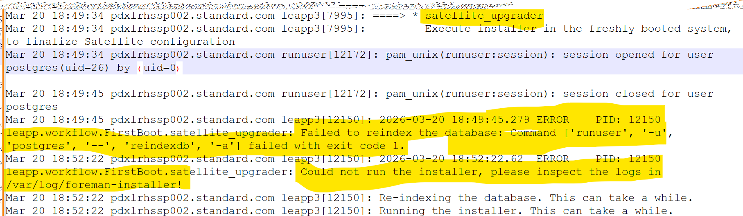

Also, it can be seen in /var/log/leapp/leapp-upgrade.log
(file attached to same folder where this document is kept)

- We tried to ping hammer but got below error:
[root@pdxlrhssp002 ~]# hammer ping
Error: Failed to open TCP connection to pdxlrhssp002.standard.com:443 (Connection refused - connect(2) for "pdxlrhssp002.standard.com" port 443)
[root@pdxlrhssp002 ~]#
- Httpd service was stopped, we tried to start (it got started but still hammer ping was not working)
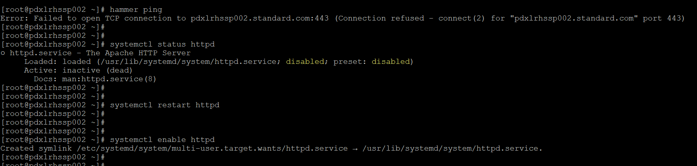
- We tried to run satellite-installer but that failed with DB migrate index error.
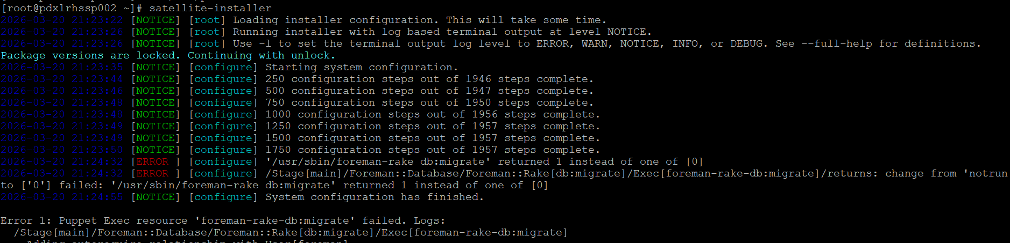
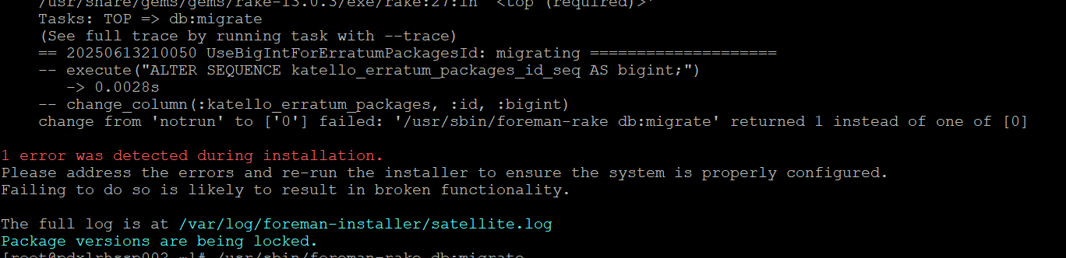
- We tried to DB migrate in foreman rake console but that failed too.
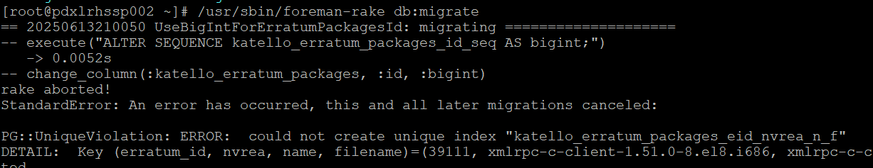
Caused by:
ActiveRecord::RecordNotUnique: PG::UniqueViolation: ERROR: could not create unique index "katello_erratum_packages_eid_nvrea_n_f"
DETAIL: Key (erratum_id, nvrea, name, filename)=(39111, xmlrpc-c-client-1.51.0-8.el8.i686, xmlrpc-c-client, xmlrpc-c-client-1.51.0-8.el8.i686.rpm) is duplicated.

Caused by:
PG::UniqueViolation: ERROR: could not create unique index "katello_erratum_packages_eid_nvrea_n_f"
DETAIL: Key (erratum_id, nvrea, name, filename)=(39111, xmlrpc-c-client-1.51.0-8.el8.i686, xmlrpc-c-client, xmlrpc-c-client-1.51.0-8.el8.i686.rpm) is duplicated.

- We looged into postgreql db to check the duplicate value:
# su - postgres -c "psql foreman"
foreman=# SELECT id, erratum_id, nvrea FROM katello_erratum_packages
WHERE erratum_id = 39111
AND nvrea = 'xmlrpc-c-client-1.51.0-8.el8.i686';
- And then I tried to delete this, and it was deleted:
foreman=# DELETE FROM katello_erratum_packages
WHERE id IN (
SELECT id FROM katello_erratum_packages
WHERE erratum_id = 39111
AND nvrea = 'xmlrpc-c-client-1.51.0-8.el8.i686'
LIMIT 1
);
DELETE 1
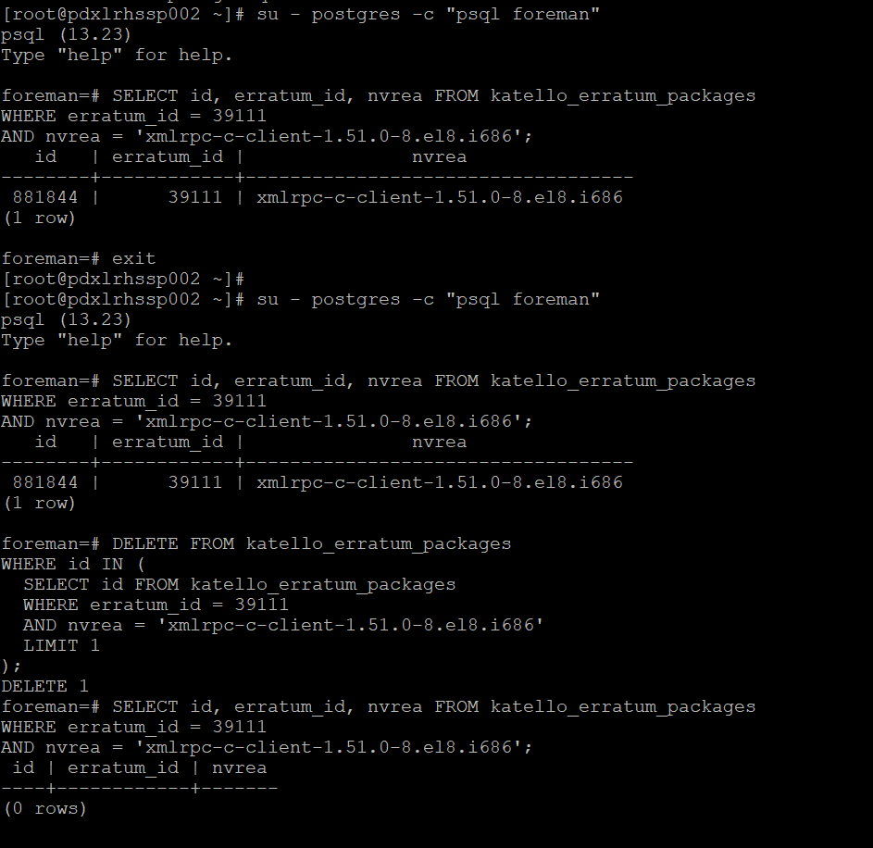

Now we thought, error is gone but we have many duplicates keys (around 147)
We ran again this command and got the same result as ERROR
# /usr/sbin/foreman-rake db:migrate

- Now we followed the article given by RH, where they asked to run all duplicate entries in one go.

https://access.redhat.com/solutions/7050470

# echo "delete from katello_erratum_packages where id in (select max(id) from katello_erratum_packages where
erratum_id in (select erratum_id from katello_erratum_packages group by nvrea, erratum_id having count(nvrea)
>1) and nvrea in (select nvrea from katello_erratum_packages group by nvrea, erratum_id having count(nvrea) >1)
and id not in (select id from katello_module_stream_erratum_packages) group by nvrea, erratum_id order by
(it deleted all 147)
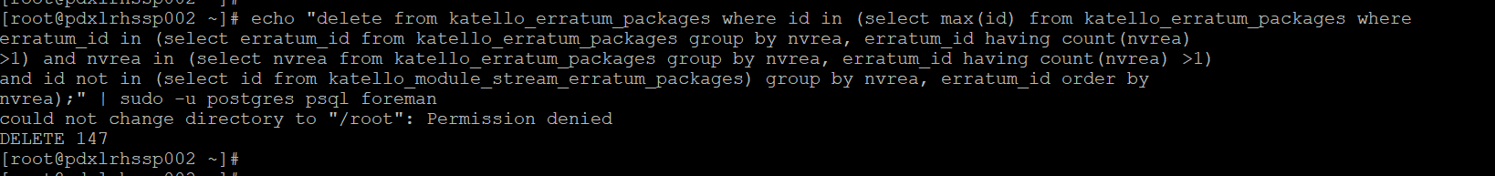

- We restarted the satellite service
# satellite-maintain service restart
- We tried to stop the maintenance mode, but it was asking hammer credentials, since hammer ping was failing so it didn’t accept the hammer password and failed.
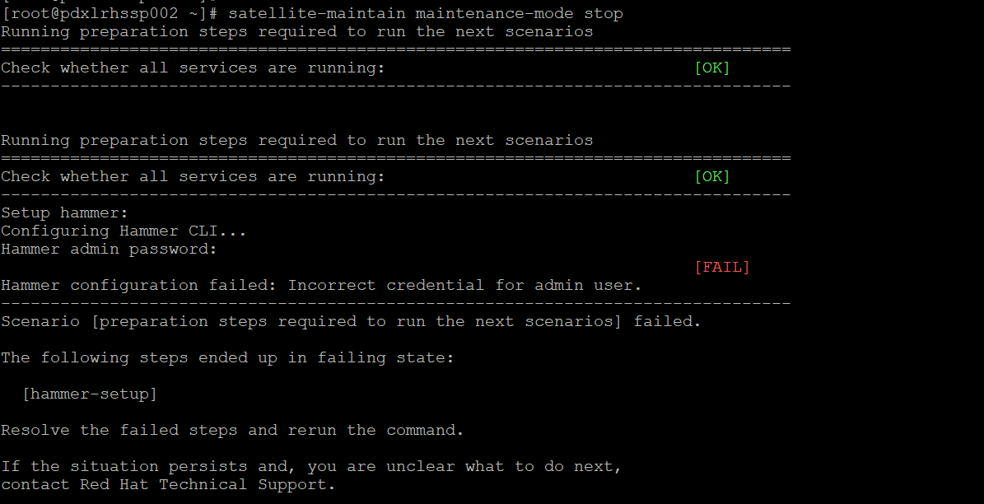
- We checked the service status they were running fine. We ran the hammer ping in debug mode and got the below error:
# hammer ping -d
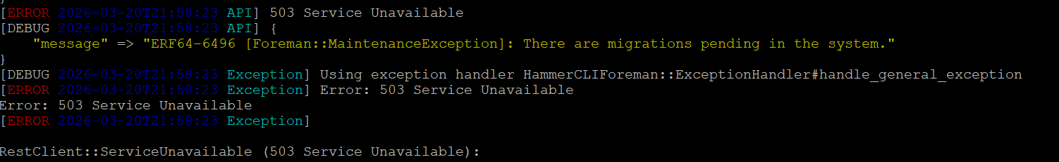
- We learned that it is because of some duplicate’s keys in DB index. So, to clear the cache we ran the satellite installer again and this time, it was good.
# satellite-installer
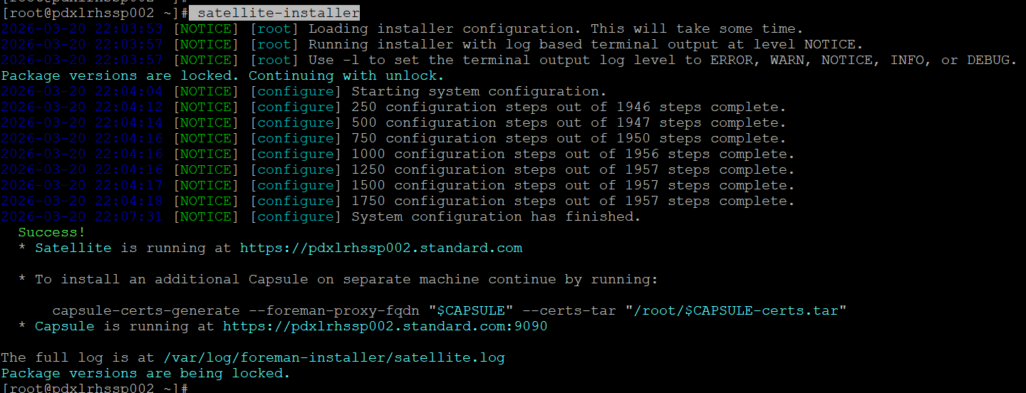
- Now, we have given a try to hammer ping, and it was also pinging this time.
# hammer ping
- As per document, we need to stop the maintenance mode, but it was already off, we verified with status
# satellite-maintain maintenance-mode status
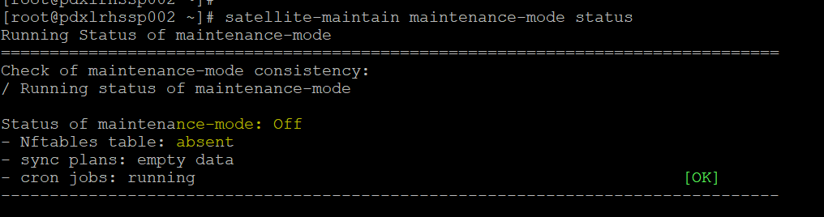
- Now, we stopped all the services except postgresql, to check the db index:
# satellite-maintain service stop --exclude postgresql
- Now, we ran the reindex command with postgres user:
# runuser -u postgres -- reindexdb -a
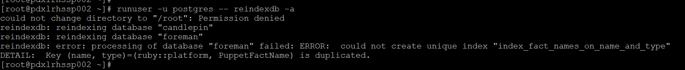
But it failed, then we follow the article below from RH:
(If the reindexdb action reports the duplication error with PuppetFactName, or Katello::RhsmFactName, or ForemanAnsible::FactName, or DiscoveryFactName, then refer to Solution 2 of solution article to resolve the conflict.)
https://access.redhat.com/solutions/6998041

- Since the duplicate key was “PuppetFactName” so we followed below steps from this article.
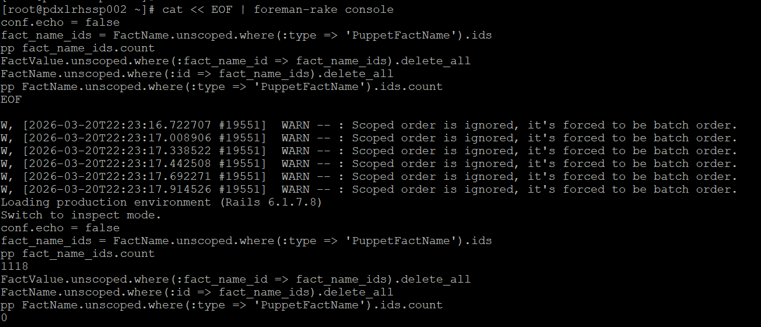
- We ran the reindexing again but we got another duplicate key.
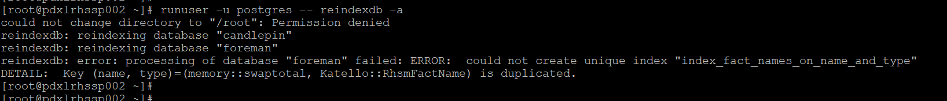
- Now the duplicate key was “RhsmFactName” so we follow below steps from the article:
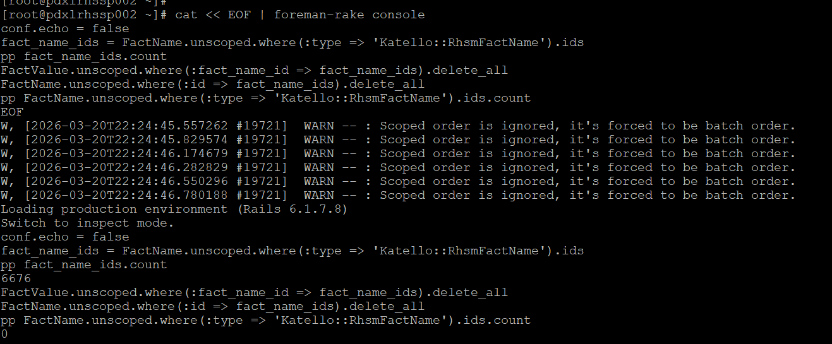
- We ran reindexing again, and now there are new error. Thank God, we are improving. And this time, it was “collation "pulp_ansible_semver" has version mismatch”
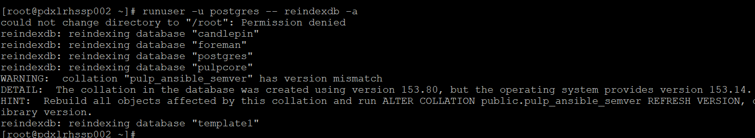
- Now it’s time to follow new article:
https://access.redhat.com/solutions/7126152
We applied the fix and reran the reindexing for DB and it got success.
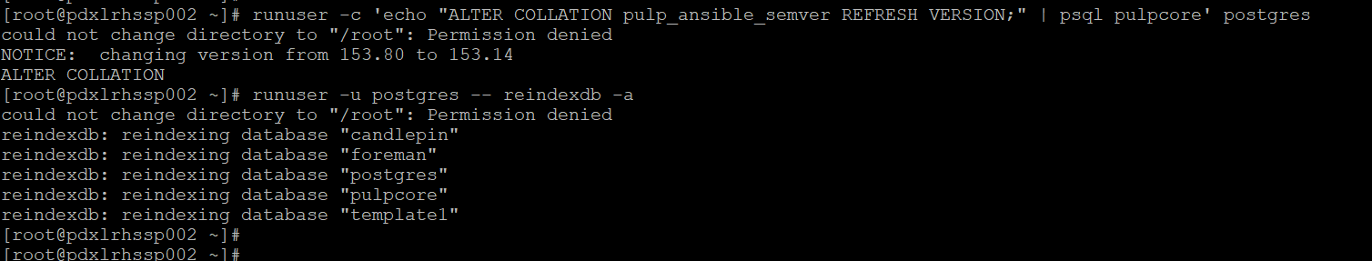
- Ran the satellite installer once again to check, it was also good.
- We checked the service status, hammer ping, all were good.
- And finally, after this much struggle we started the upgrade again, and we finished successfully.
# satellite-maintain self-upgrade
# satellite-maintain upgrade check
# satellite-maintain upgrade run
-------------------------------------------------------------------------------------------------------------------
Upgrade finished.

- Rebooted the server and checked all the service. We are good.

Everybody GOOD WORK!!!!

